Customer Shopping Behavior Analysis

1.Project Overview
The objective of this project is to analyze customer shopping behavior and identify purchasing patterns, customer preferences, and revenue trends. The insights generated can help businesses make data-driven decisions related to marketing, customer retention, and sales optimization.

2. Tools & Technologies Used
Tool | Purpose
Excel | Initial data inspection and cleaning
Python (Pandas, NumPy) | Data preprocessing and analysis
PostgreSQL | Data storage and querying
Power BI | Dashboard creation and visualization

3. Dataset Information
Dataset Size: 3,900 records
Features Included
- Customer ID
- Age
- Gender
- Item Purchased
- Category
- Purchase Amount
- Location
- Season
- Review Rating
- Subscription Status
- Shipping Type
- Discount Applied
- Promo Code Used
- Previous Purchases
- Payment Method
- Frequency of Purchases

4. Data Processing Steps
Excel
- Checked missing values
- Verified data consistency
- Performed preliminary exploration
Python
- Cleaned and transformed data
- Created Age Groups
- Performed exploratory data analysis (EDA)
PostgreSQL
- Imported cleaned dataset
- Executed SQL queries for aggregation and analysis
Power BI
- Built interactive dashboard
- Added slicers and KPI cards
- Created visual reports

5. Exploratory Data Analysis (EDA) Using Python
1. Loading the Dataset
Purpose: The dataset was loaded into Python for analysis and data preparation.
Output:
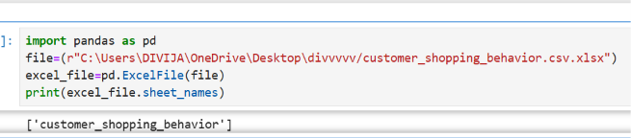

2. Checking Dataset Shape
Purpose: To find the total number of rows and columns in the dataset.
Output:
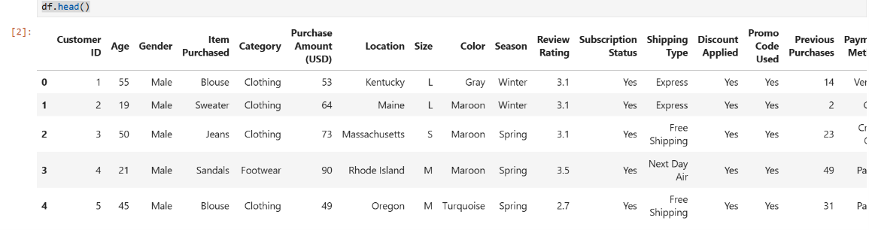
Description: The dataset contains customer shopping information with multiple records and features for analysis.

3. Checking Dataset Information
Purpose: To understand the data types and structure of the dataset.
Output:
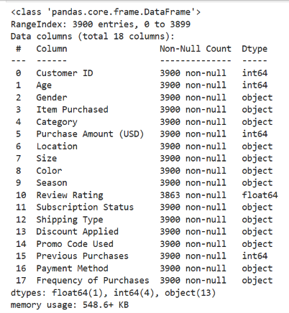
Description: This step helped identify numerical and categorical columns and verify that the data was loaded correctly.

4. Statistical Summary
Purpose: To understand the basic statistics of numerical columns.
Output:

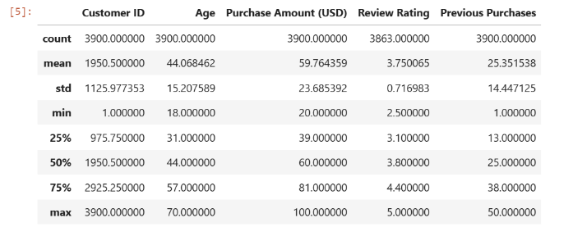

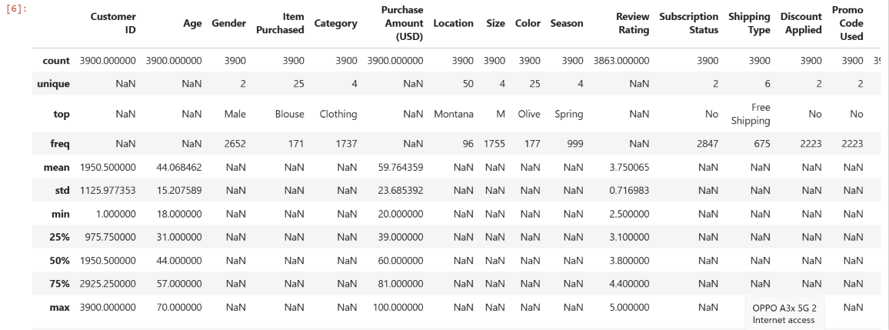
Description: This analysis provided information such as average, minimum, maximum, and distribution of values in the dataset.

5. Missing Value Analysis
Purpose: To identify missing values in the dataset.
Output :
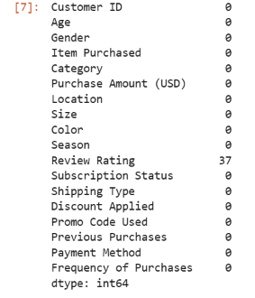

Description: Missing values were checked to ensure data quality before performing further analysis.

6. Handling Missing Values
Purpose: To improve data quality by treating missing values.
Output:
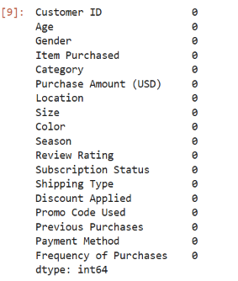
Description: Missing values in the Review Rating column were filled using appropriate methods to avoid data loss.

7. Standardizing Column Names
Purpose: To make column names consistent and easy to use.
Output:

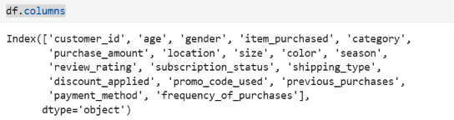
Description: Column names were converted into a standard format for easier querying and analysis.

8. Creating Age Group Column
Purpose: To group customers based on age ranges.
Output:
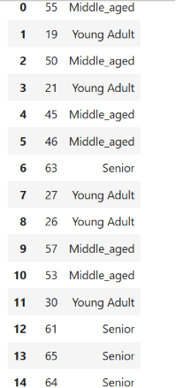
Description: Customers were divided into age groups to better understand purchasing behavior across different age categories.

9. Creating Purchase Frequency Days Column
Purpose: To convert purchase frequency into numerical values for analysis.
Output:
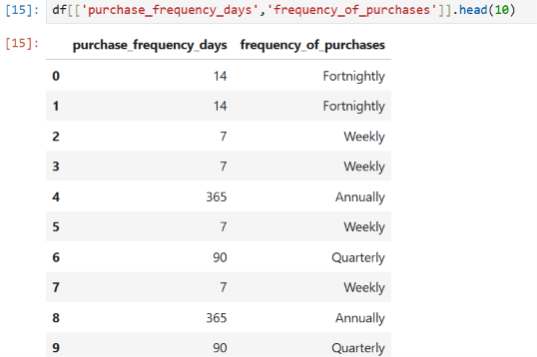

Description: A new column was created to represent purchase frequency in days, making it easier to perform calculations and comparisons.

10. Comparing Discount Applied and Promo Code Used
Purpose: To check whether both columns contained similar information.
Output:
Description: The relationship between discount usage and promo code usage was analyzed to identify duplicate information.

11. Removing Unnecessary Column
Purpose: To eliminate redundant data from the dataset.
Output:
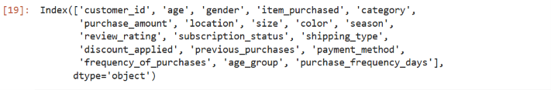
Description: One column was removed because it contained information already available in another column.

12. Loading Data into PostgreSQL
Purpose: To store the cleaned dataset in PostgreSQL for querying and analysis.
Output:
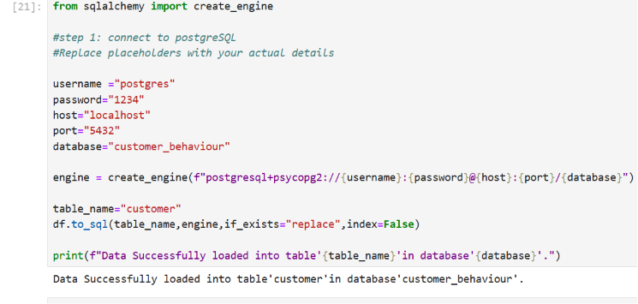
Description: The cleaned dataset was successfully loaded into PostgreSQL for further analysis and dashboard development.

Conclusion
The EDA process helped understand the dataset, improve data quality, create useful features, and prepare the data for PostgreSQL analysis and Power BI dashboard development.

6.Postgresql Analysis
select * from customer limit 20
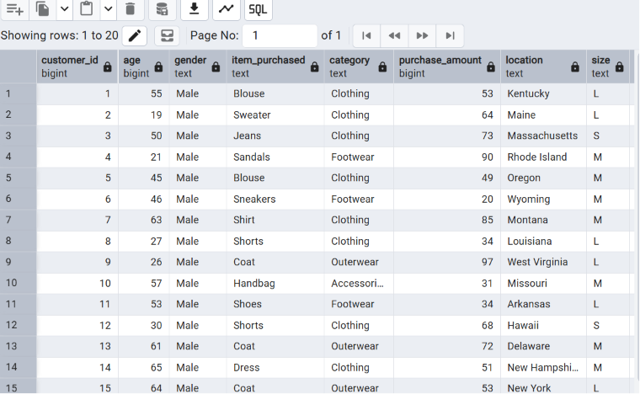

1.
Q1. Which customers used a discount but still spent more than the average purchase amount?
select customer_id,purchase_amount
from customer
where discount_applied='Yes' and purchase_amount >= (select AVG(purchase_amount) from customer)
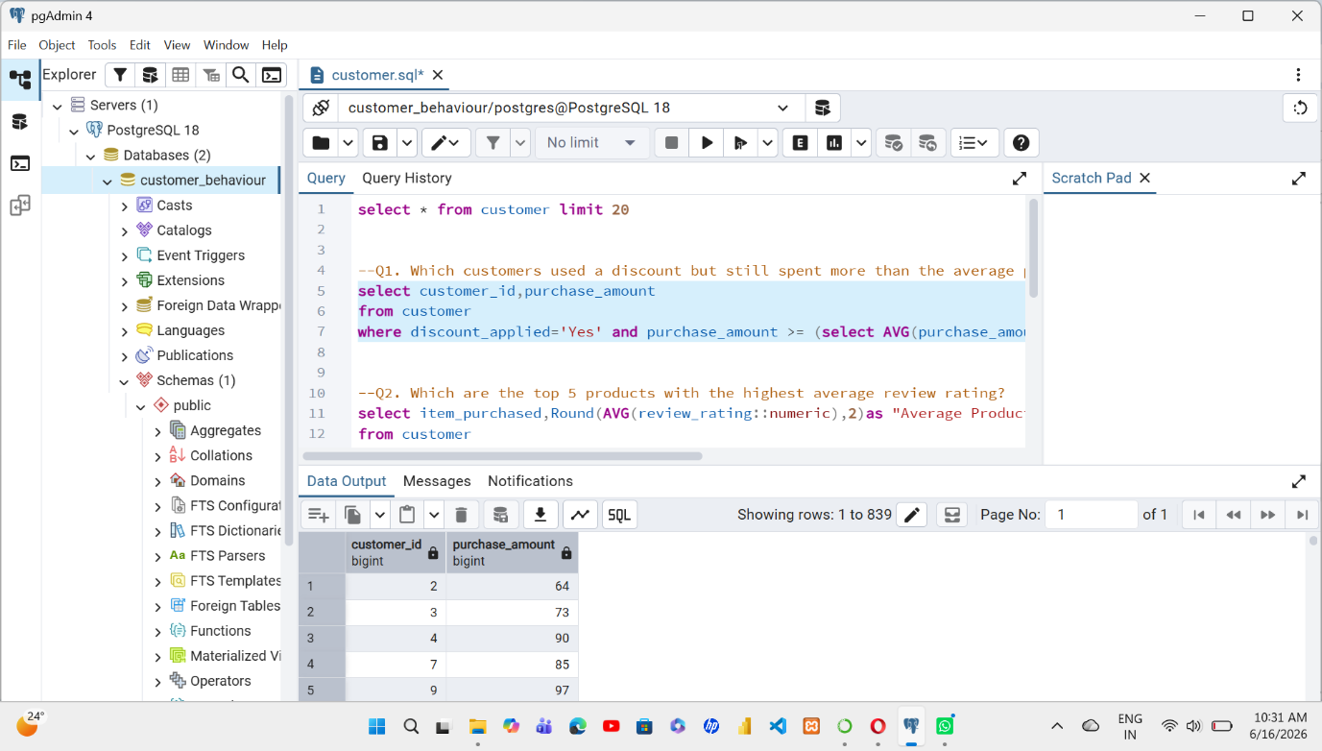

2.

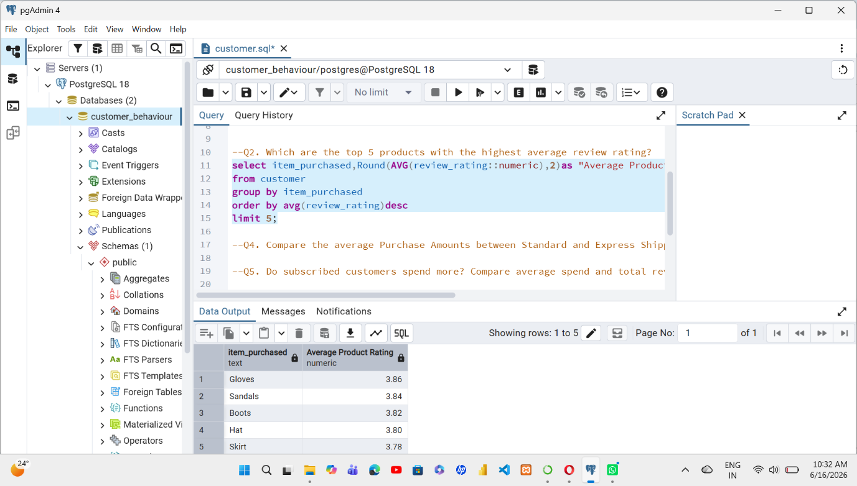
Output:

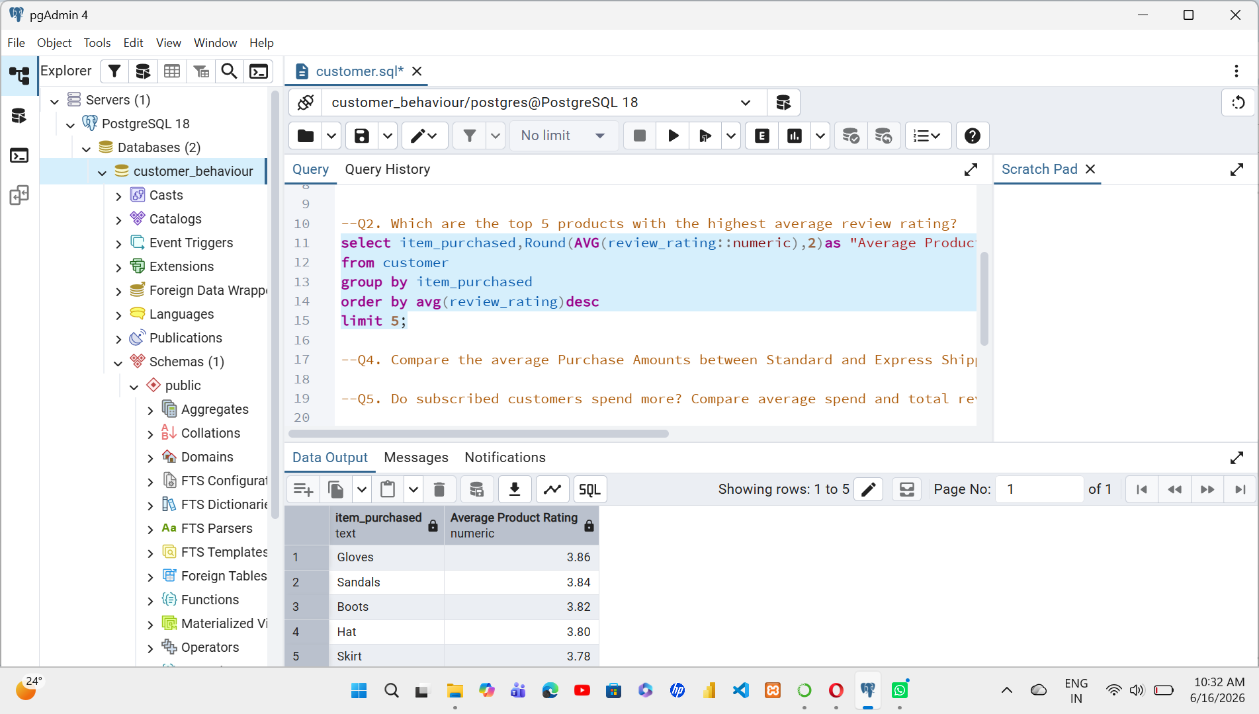

3.
Q3. Compare the average Purchase Amounts between Standard and Express Shipping.
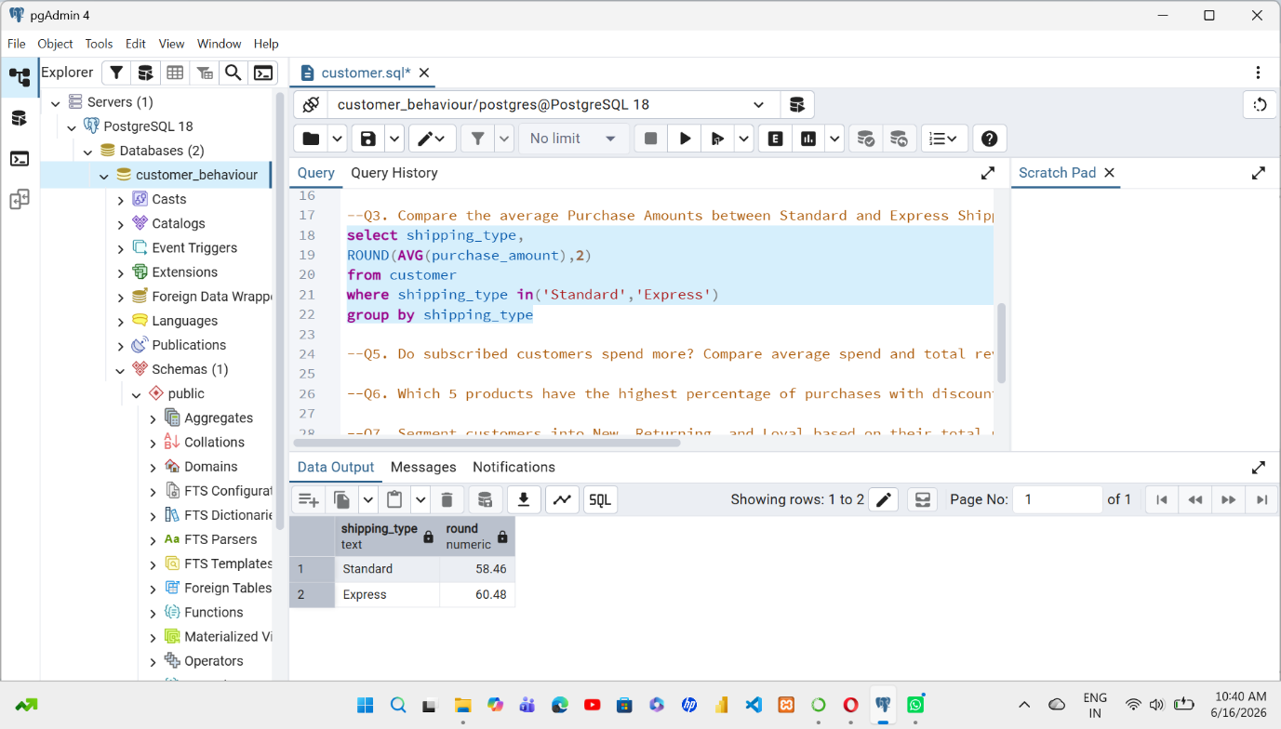
Output:

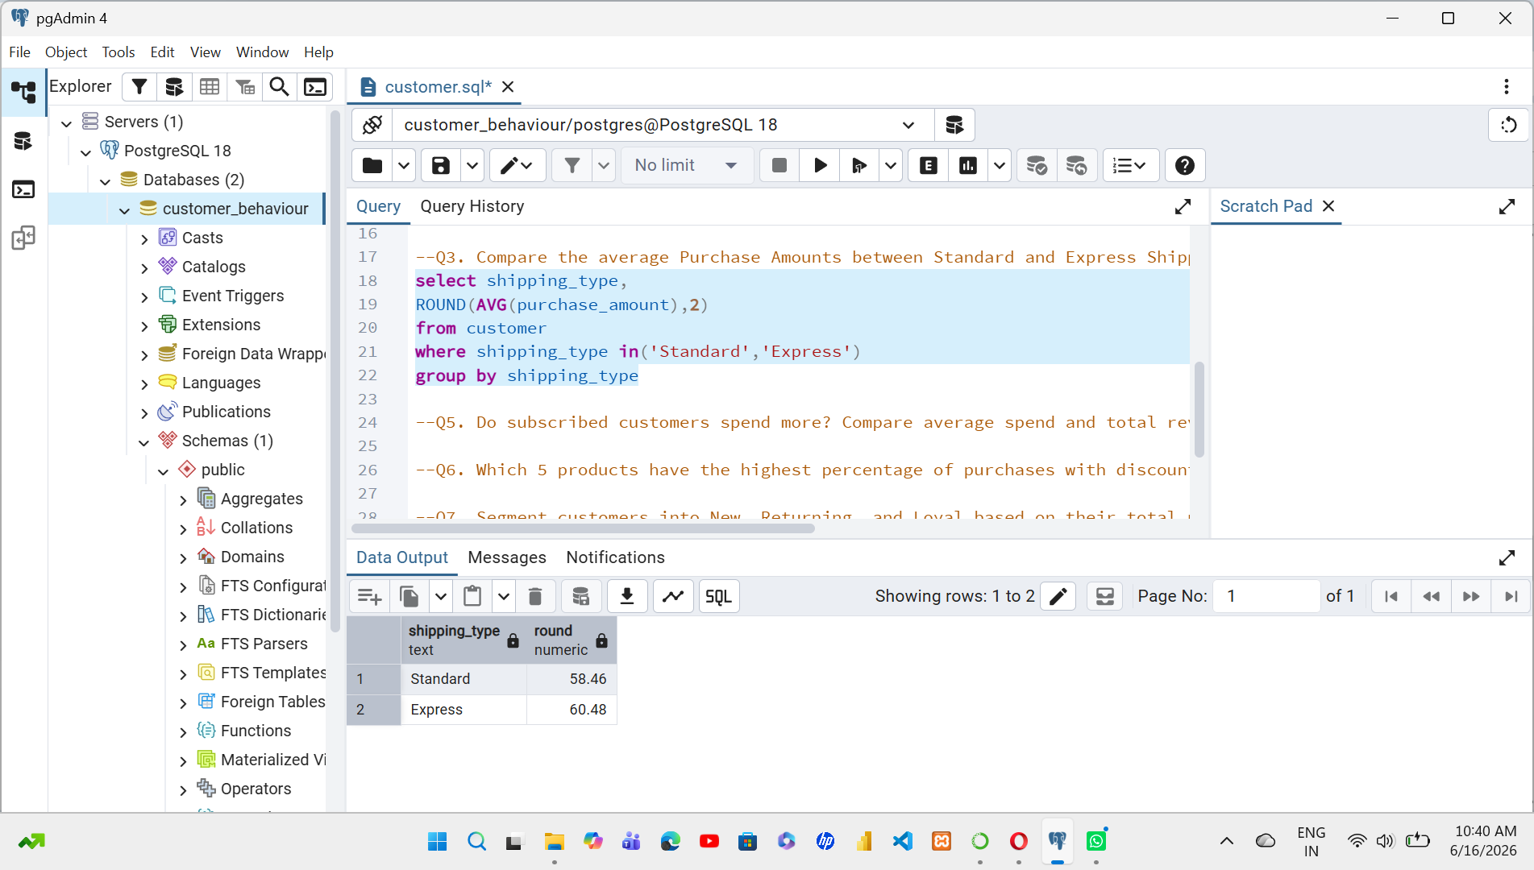

4.
Q4. Do subscribed customers spend more? Compare average spend and total revenue between subscribers and non-subscribers
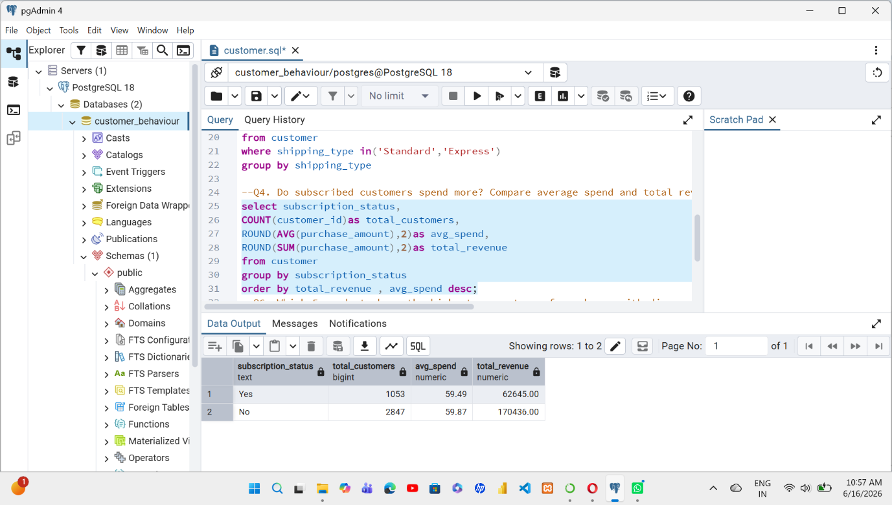

7.Business Recommendations
- Enhance Customer Retention - Identify customer preferences to improve customer satisfaction and loyalty.
- Boost Subscription – Promotes Exclusive benefits For Subscriptions
- Review Discount Policy – balance sales boosts with margin Control

